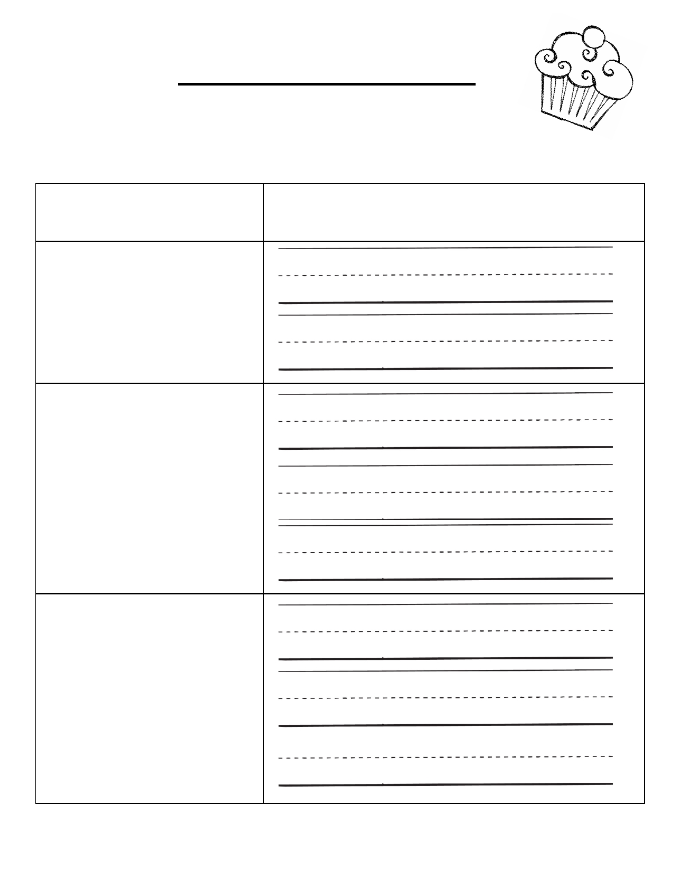
If You Give a Cat a CupCake
Cause and Effect

Cause Effect

If You Give a Cat a CupCake
Cause and Effect

Cause Effect

